Owner:

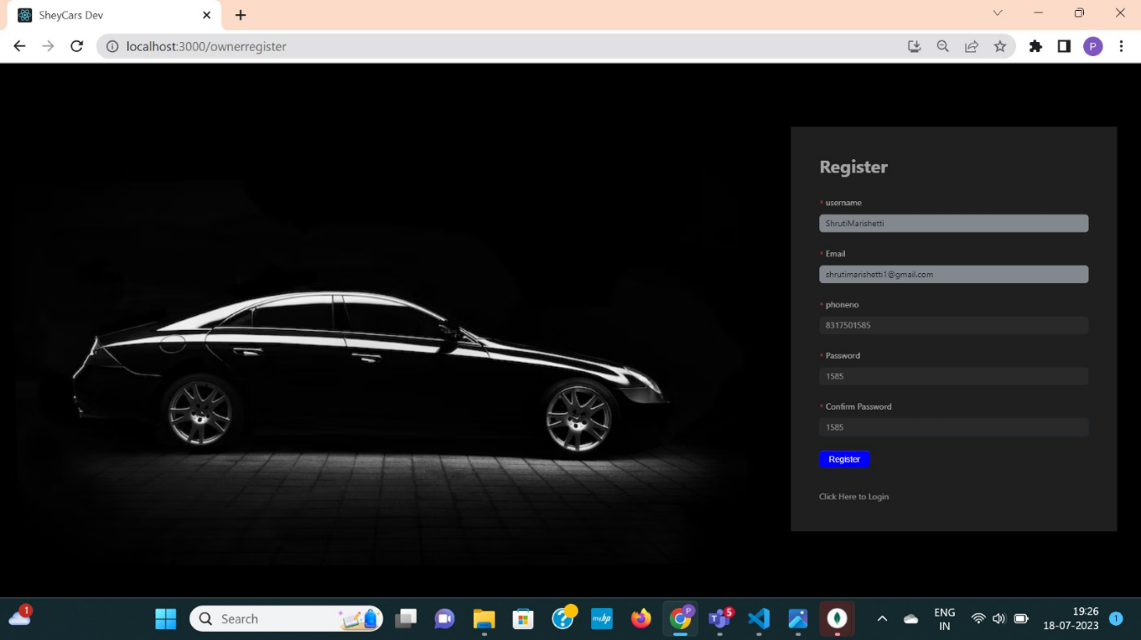

Fig 6.1.1 Car owner register into website

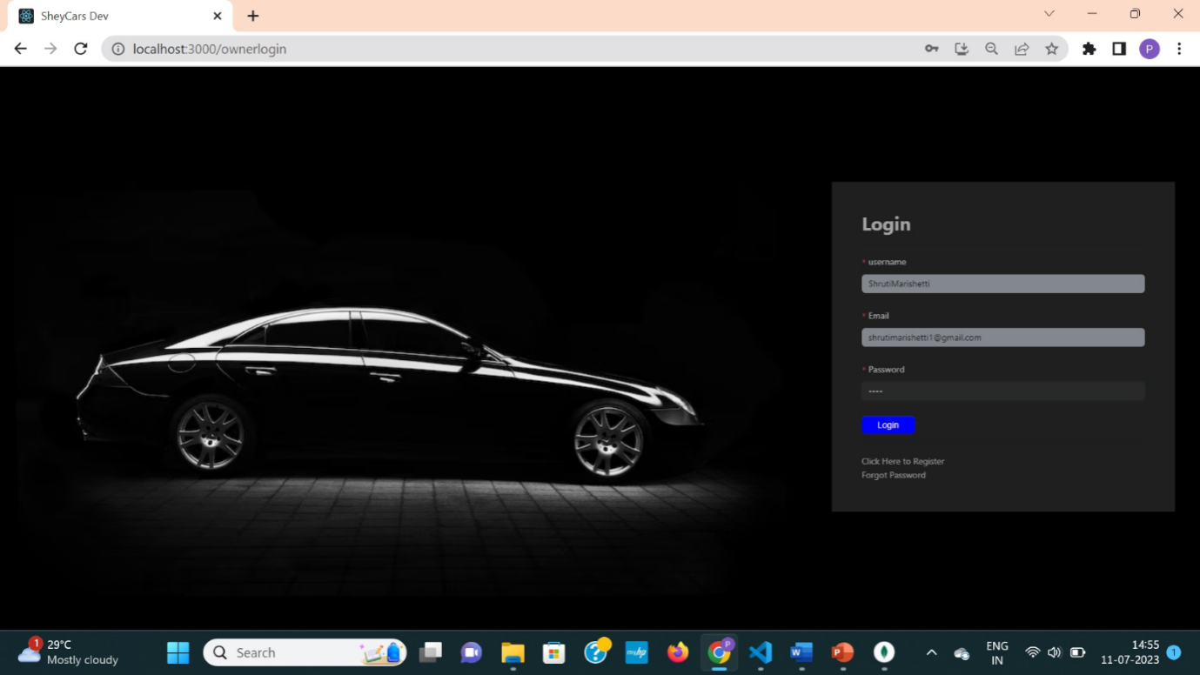

Fig 6.1.2 Owner logins into his/her account.

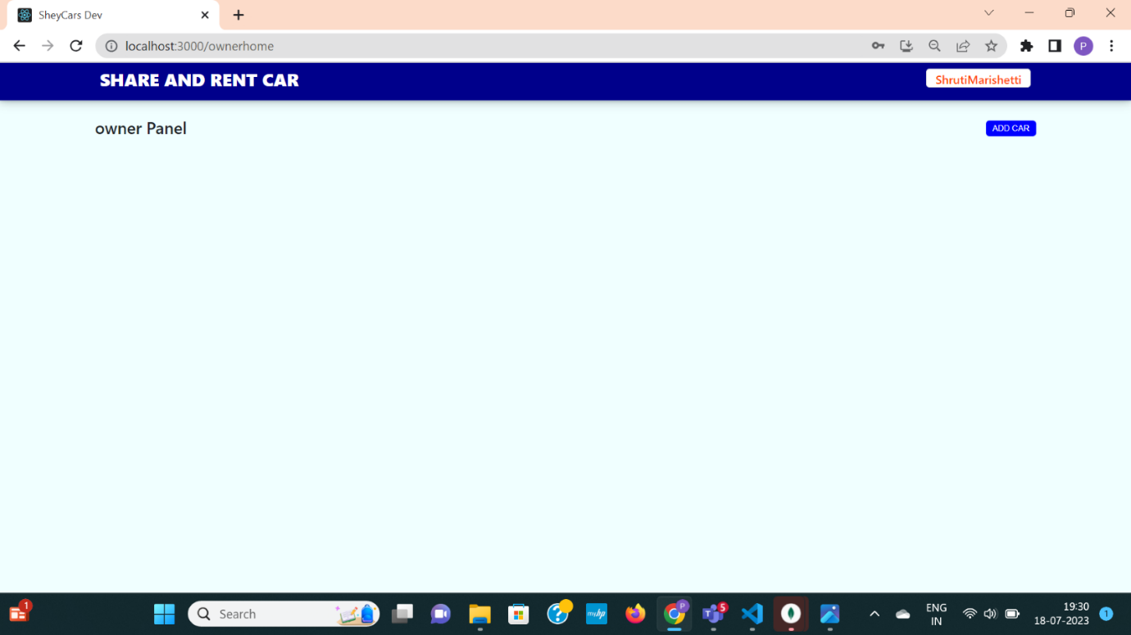

 Fig 6.1.3 Empty car page of owners new account

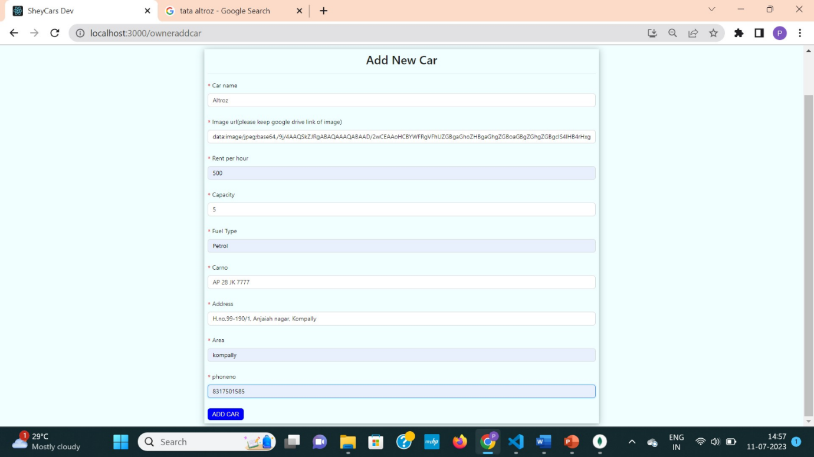

Fig 6.1.4 Add new car page to upload new car

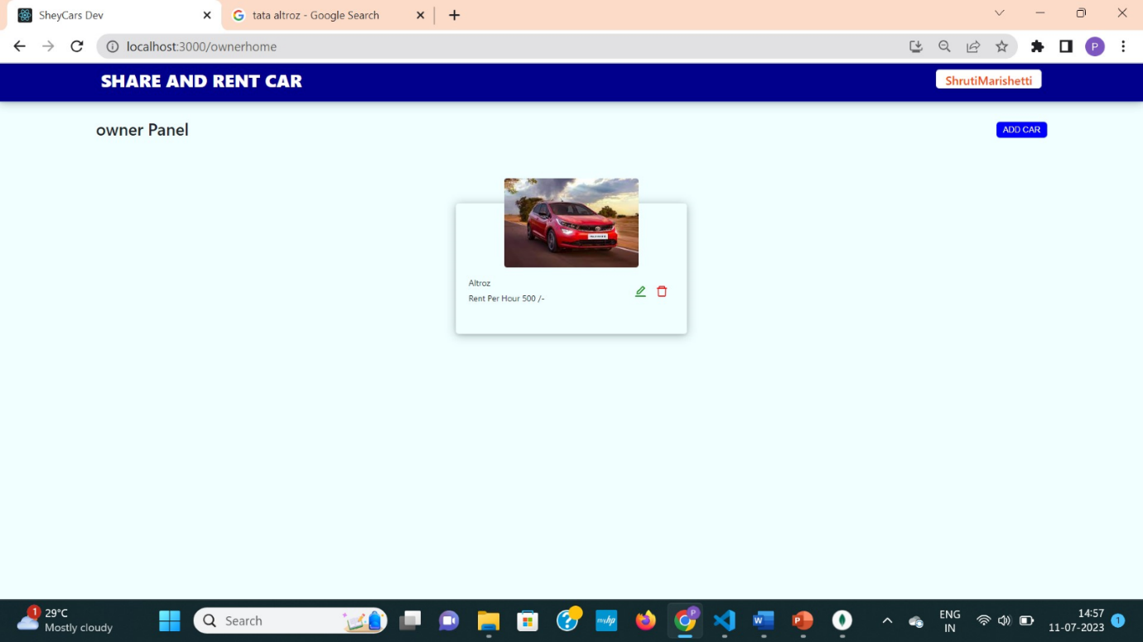

 Fig 6.1.5 Car page of owner with newly uploaded car

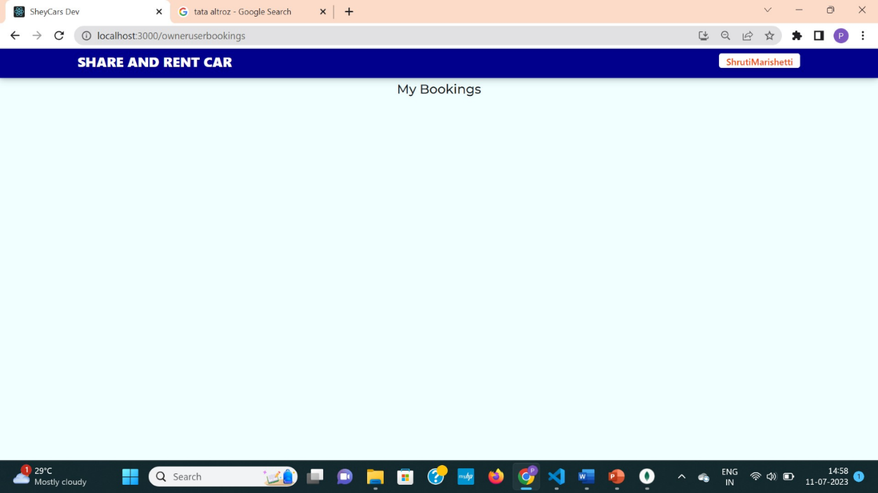

 Fig 6.1.6 Empty bookings page as no one booked has booked that car

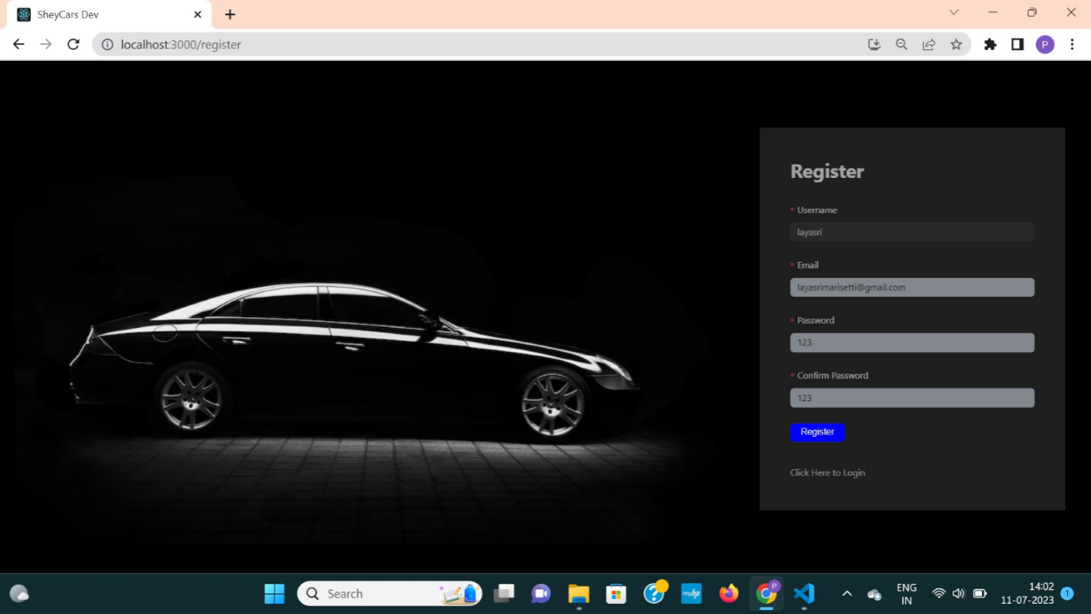

 Fig 6.1.7 Customer register into website

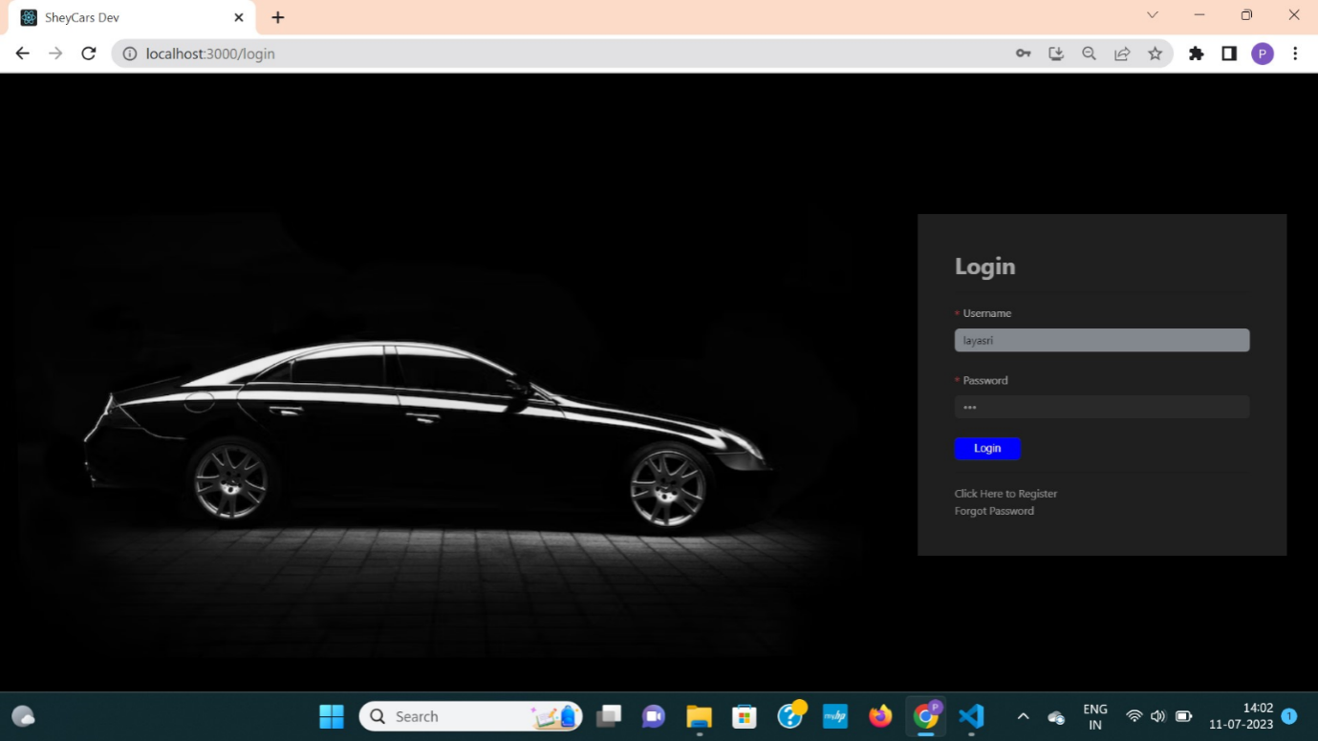

Fig 6.1.8 Customer logs into their account

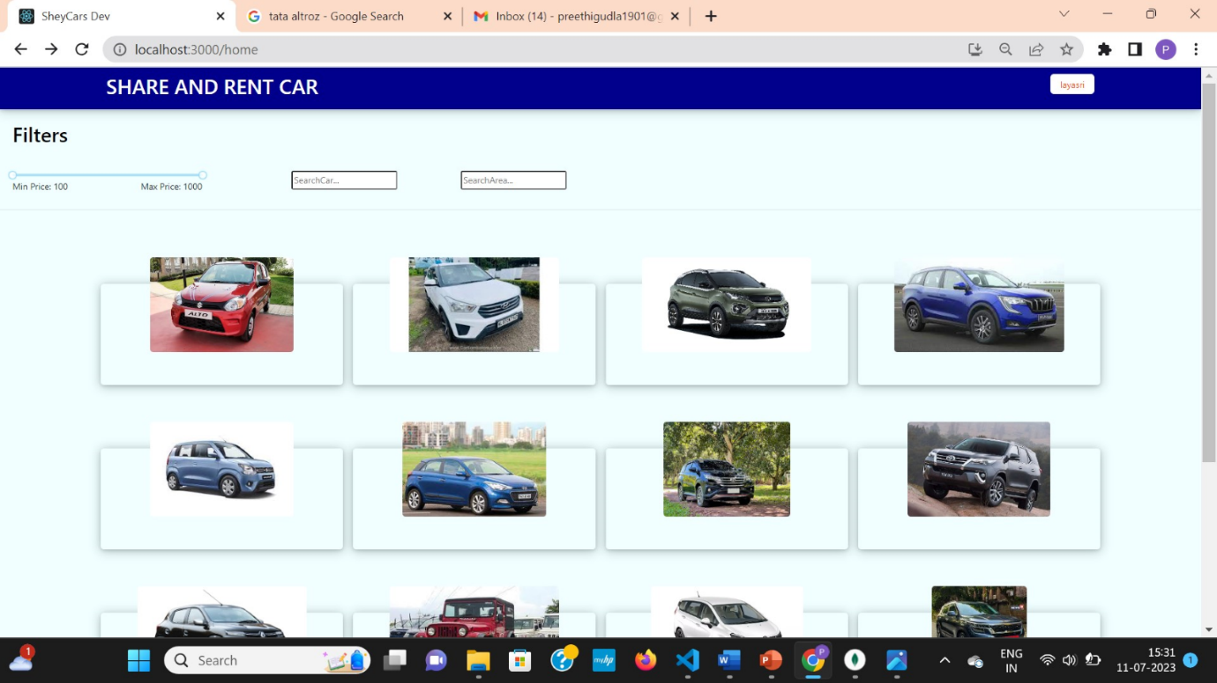

 Fig 6.1.9 Customer can view all available cars in website after logging in.

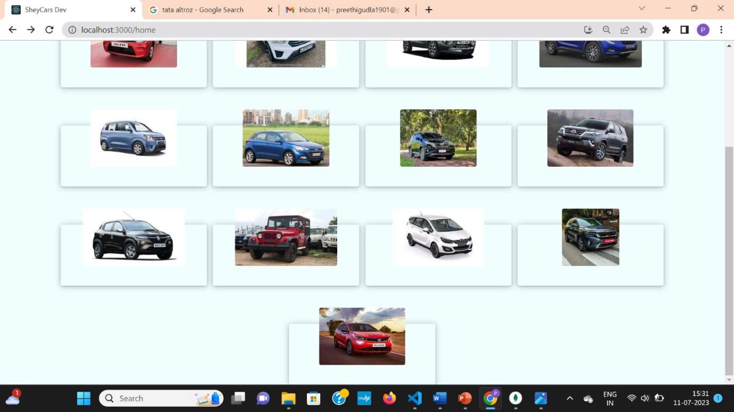

  Fig 6.1.10 Customer can view all available cars in website after logging in.

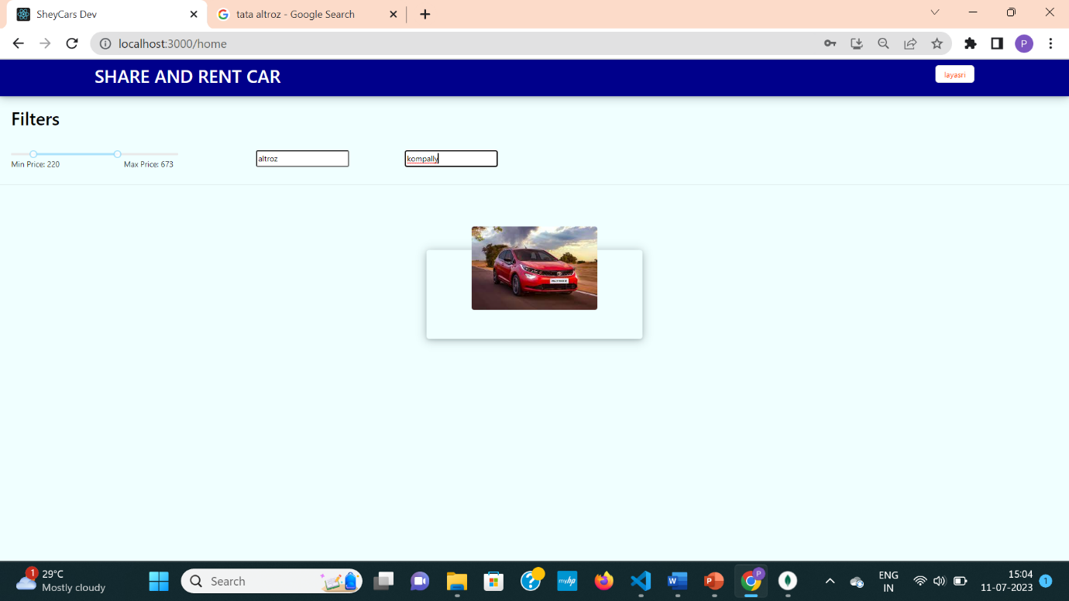

 Fig 6.1.11 Customer is applying filters and filtering out cars and select one car

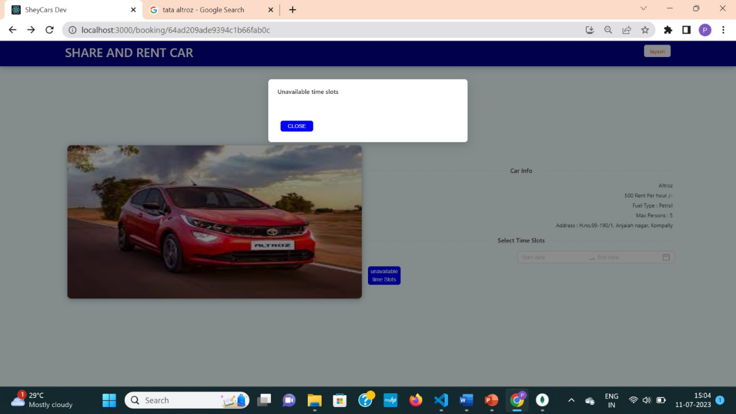

 Fig 6.1.12 Customer is checking unavailable time slots of car

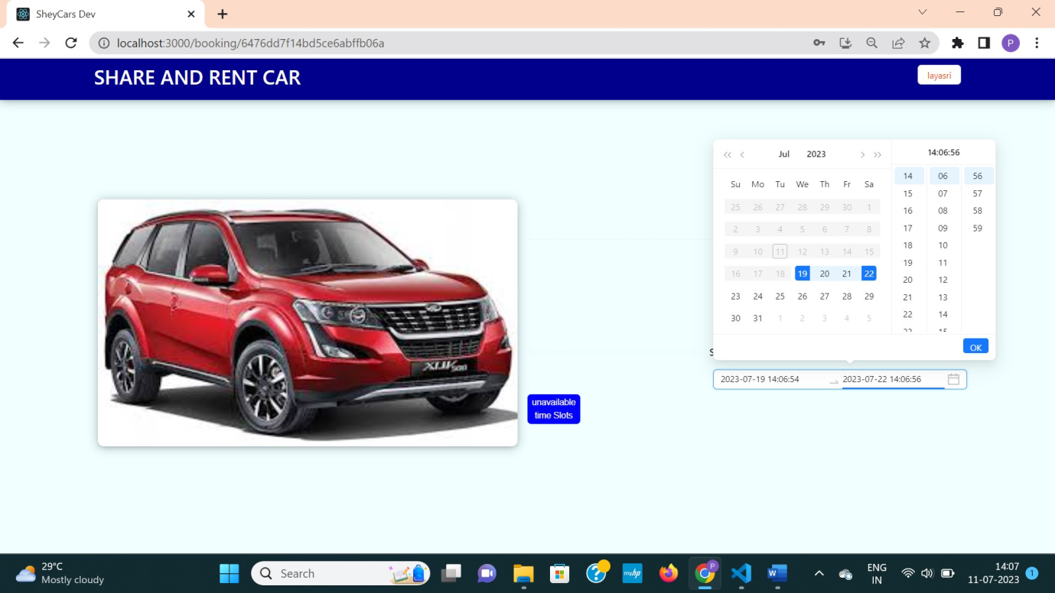

Fig 6.1.13 Customer selecting time slots

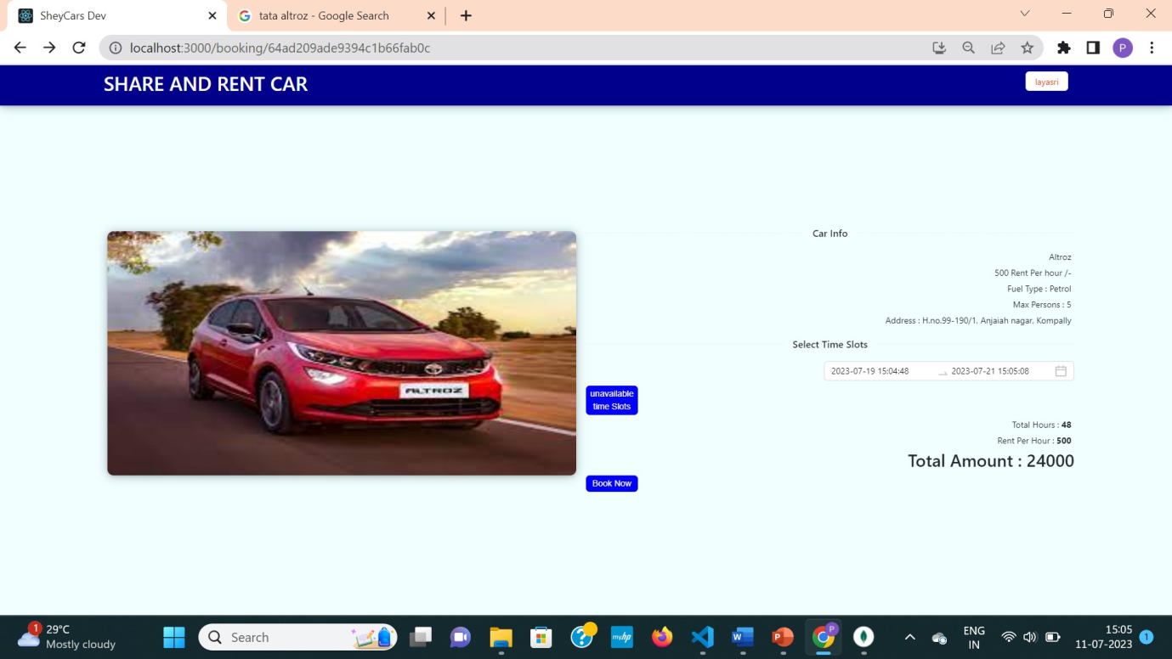

Fig 6.1.14 Customer can see total amount for selected time slot

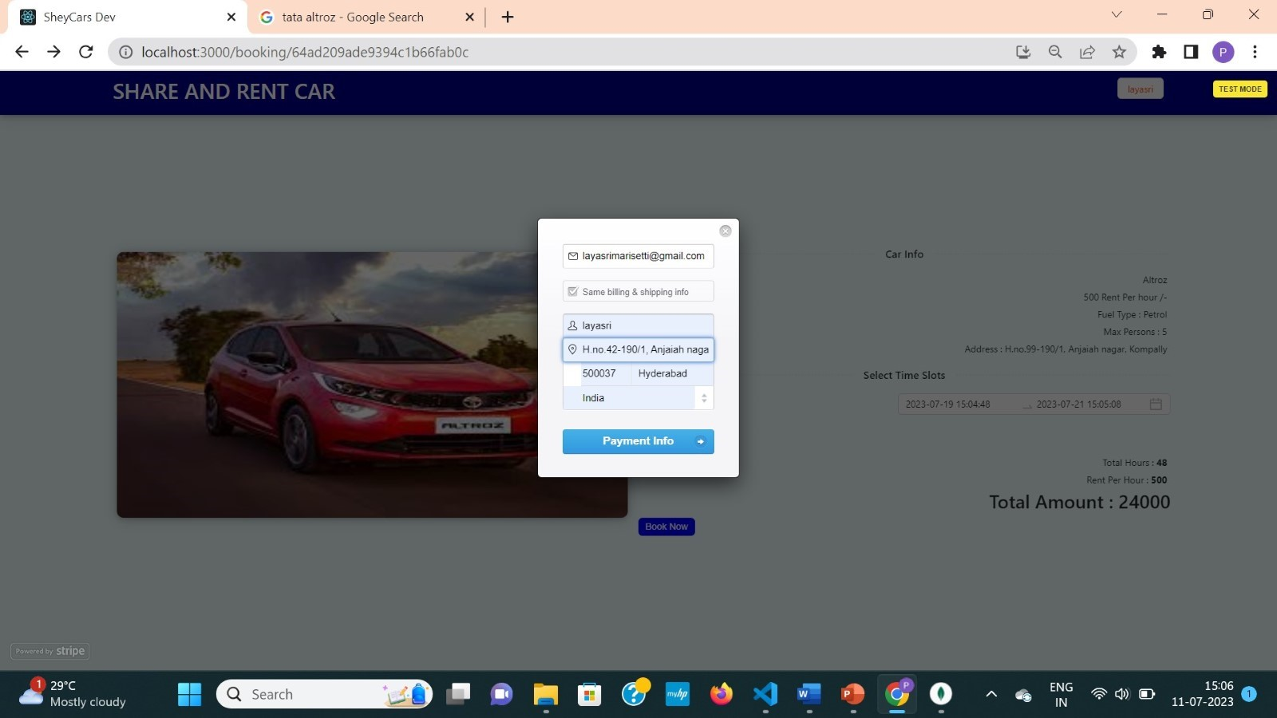

Fig 6.1.15 Customer entering their details to pay

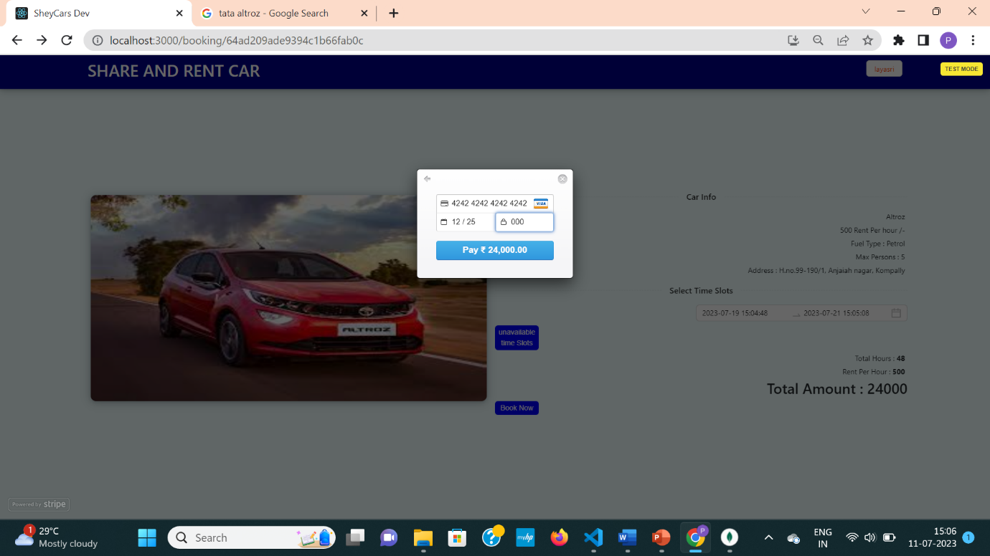

Fig 6.1.16 Customer entering credit card details to complete payment process

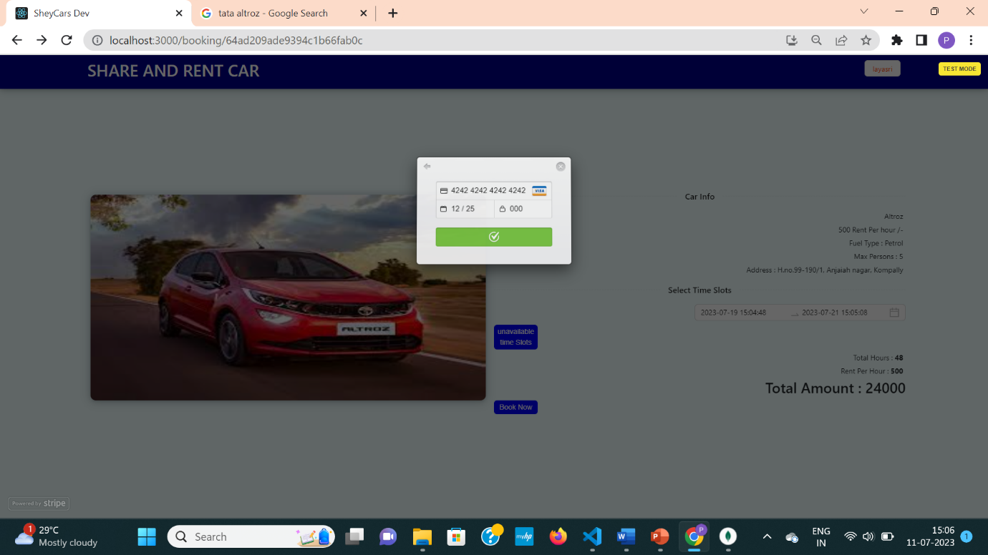

Fig 6.1.17 Customer Payment successful

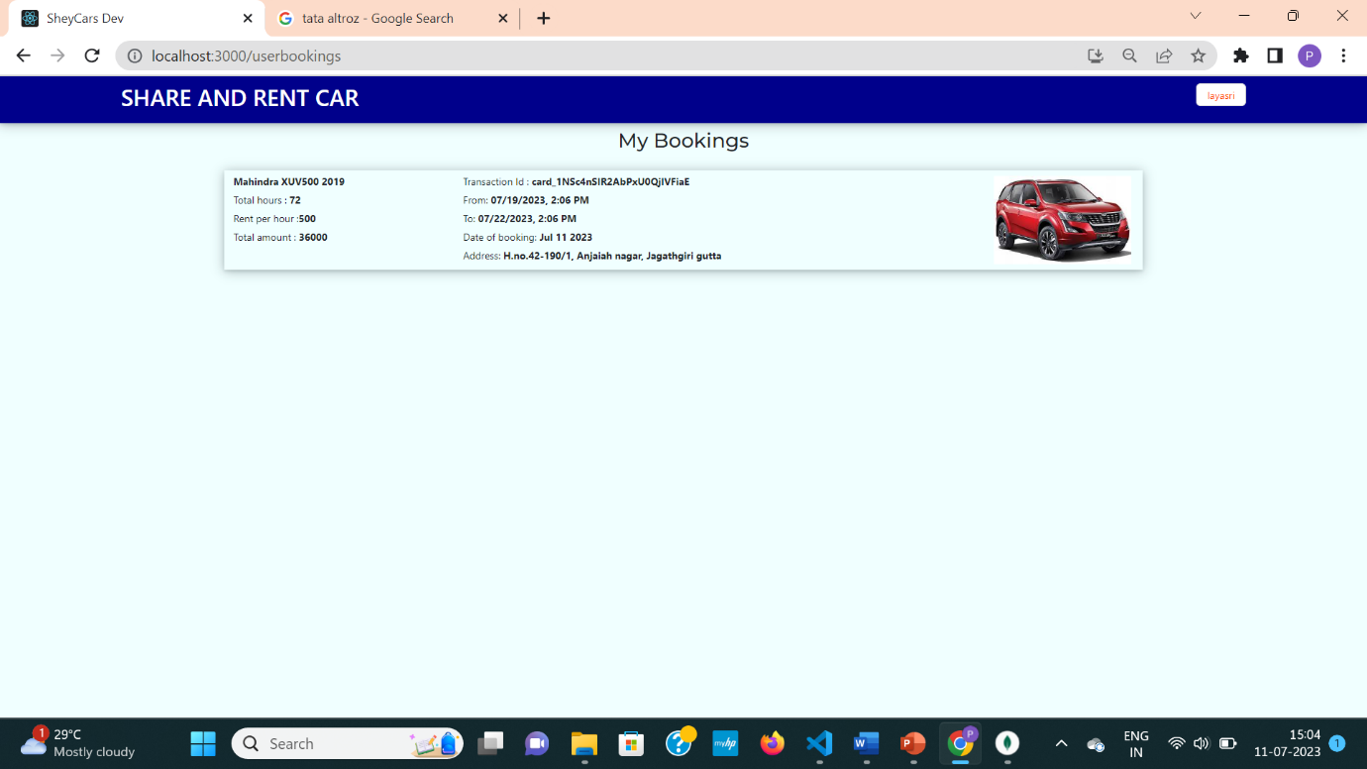

Fig 6.1.18 Booking will be updated in customer booking page

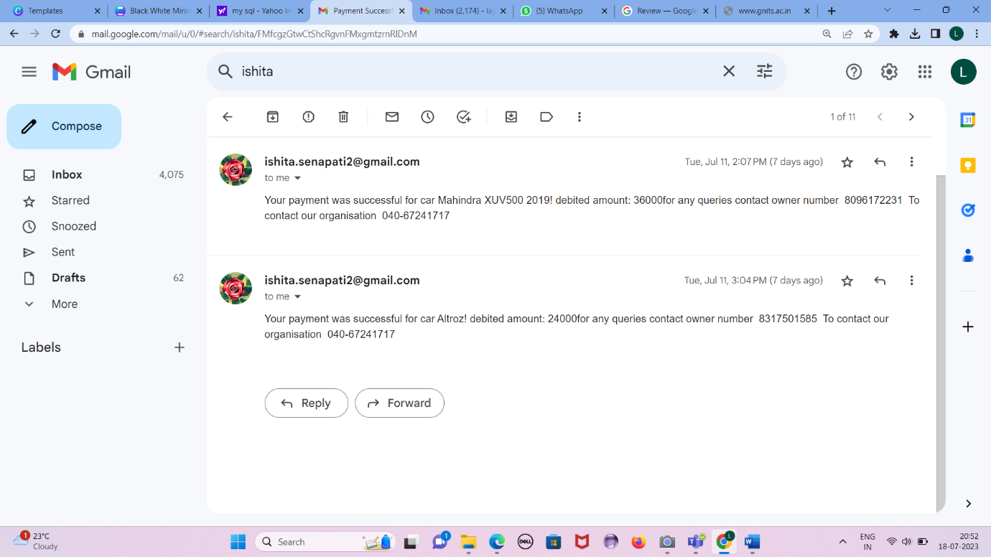

Fig 6.1.19 Customer receive mail of Payment successful and car owner details

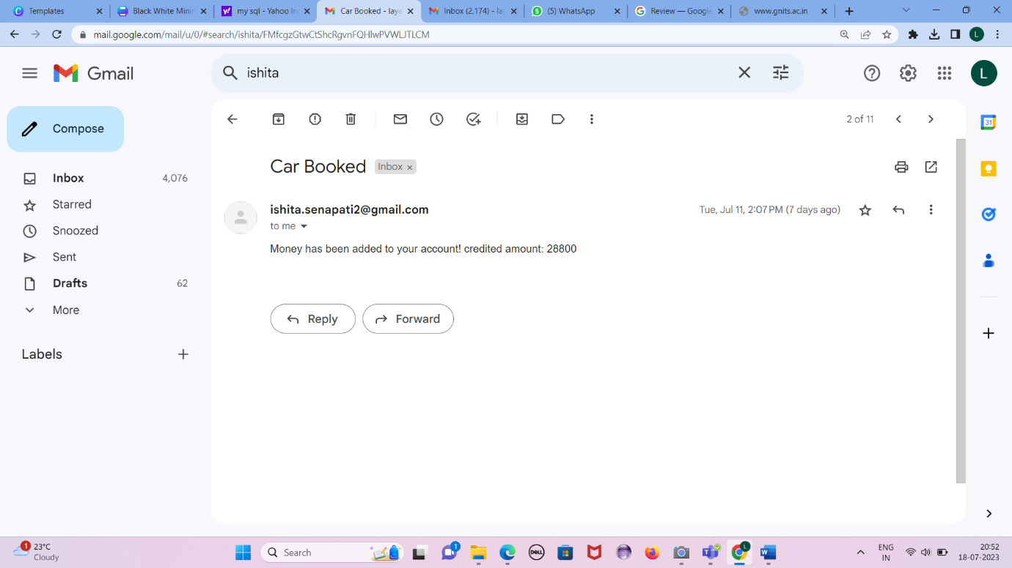

Fig 6.1.20 Customer will receive mail of amount debited.

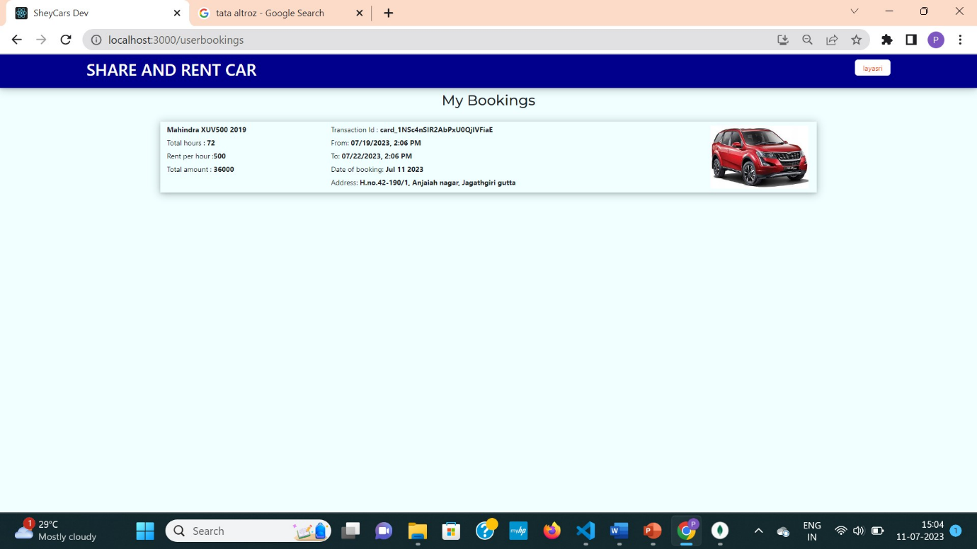

Fig 6.1.21 Booking will be updated in Owner booking page

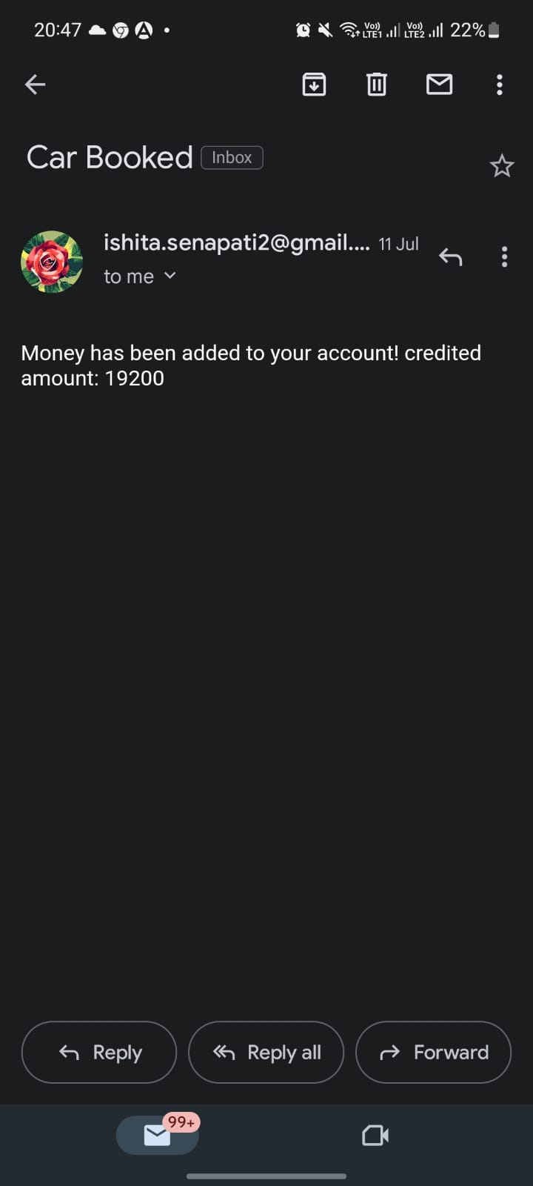

Fig 6.1.22 Car Owner will receive mail of amount credited

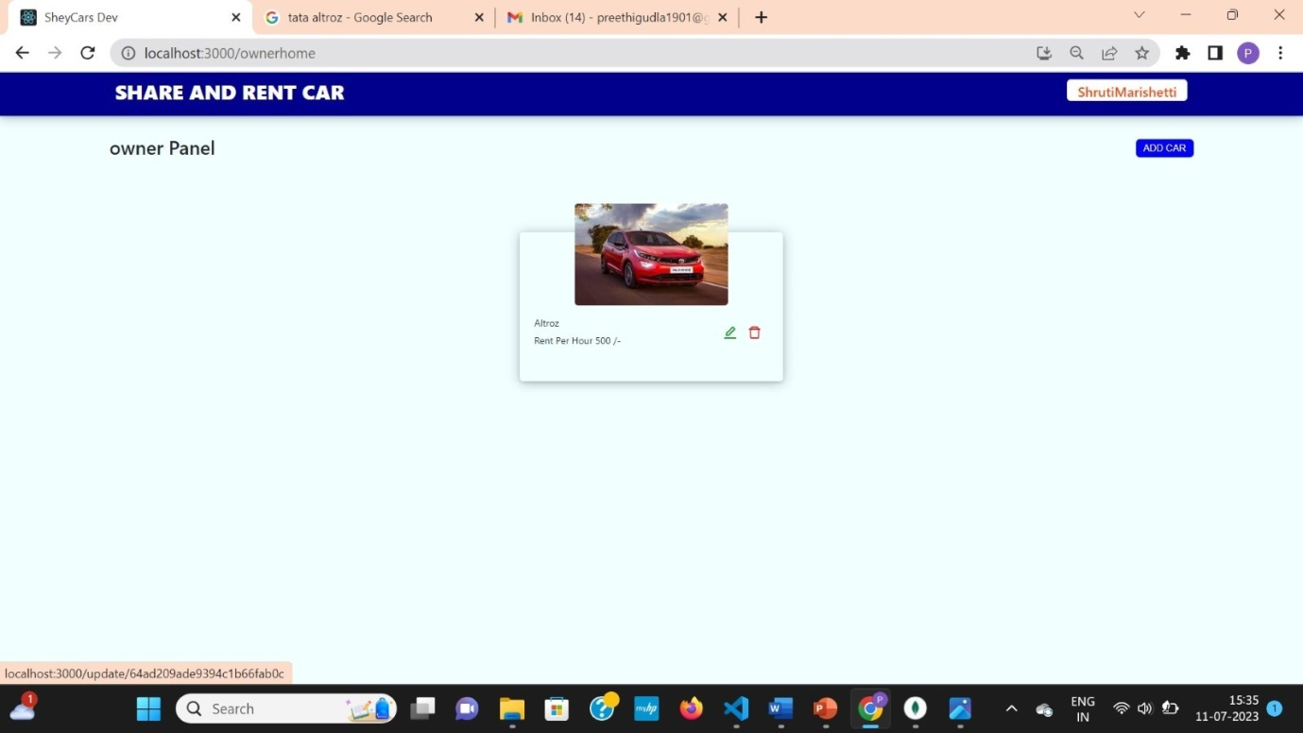

 Fig 6.1.23 Car Owner can edit car by clicking on green button below car image.

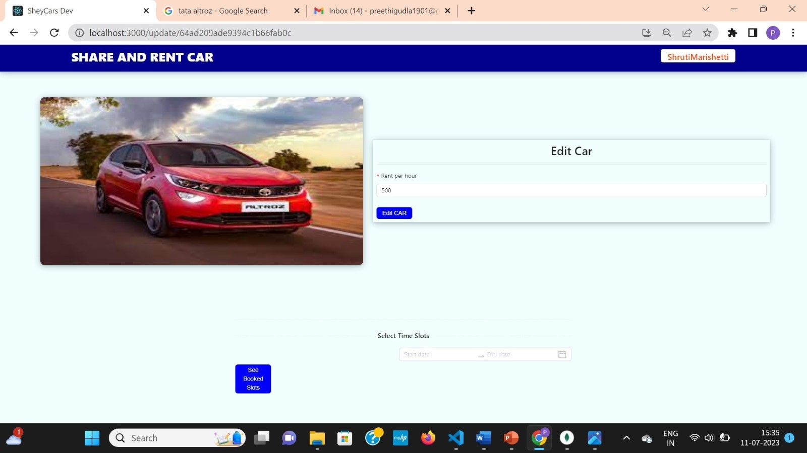

Fig 6.1.24 Car Owner can edit price and available time slots.

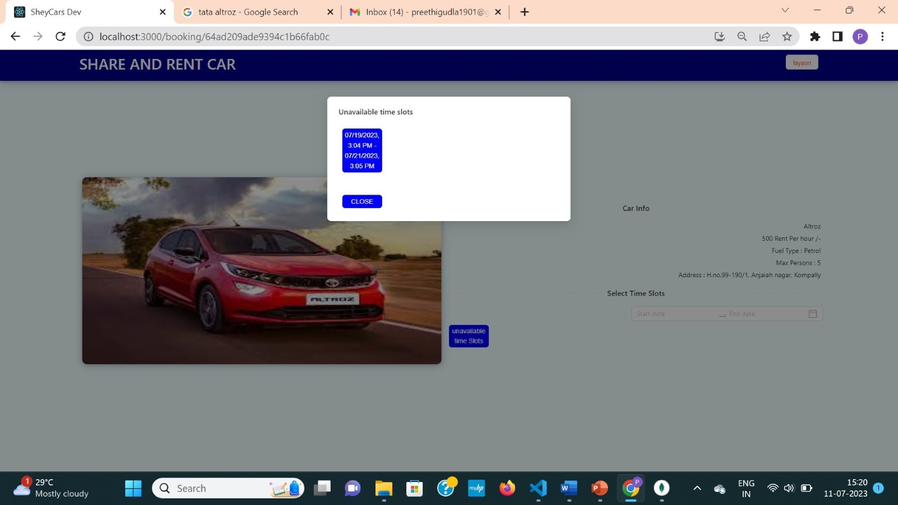

Fig 6.1.25 Unavailable slots of car on customers side.

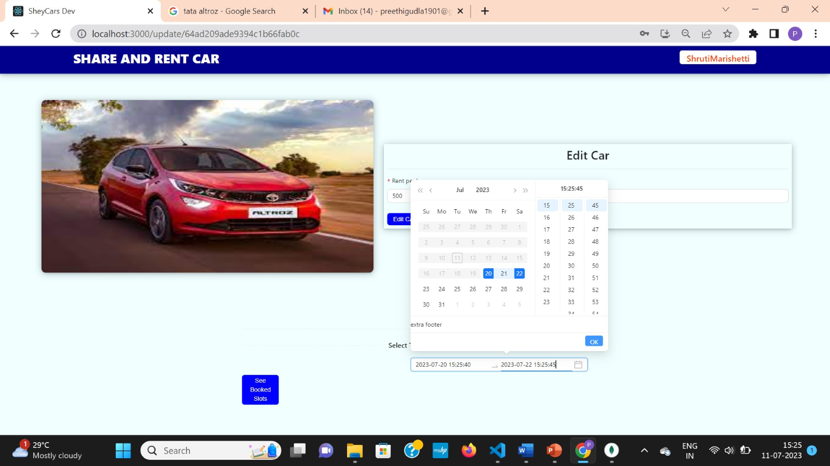

Fig 6.1.26 Car owner trying to make booked time slot unavailable.

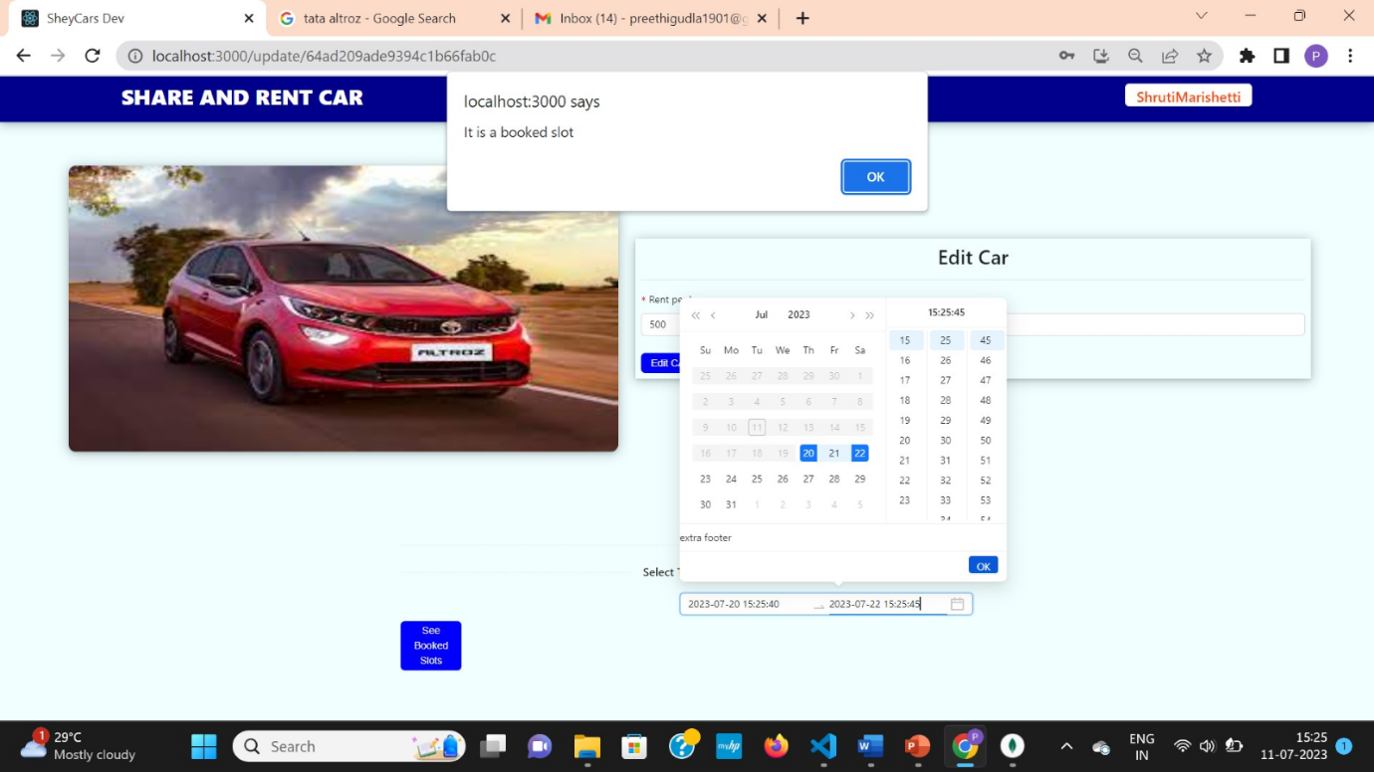 Fig 6.1.27 Car owner is alerted when trying to make aalredy booked time slot unavailable.

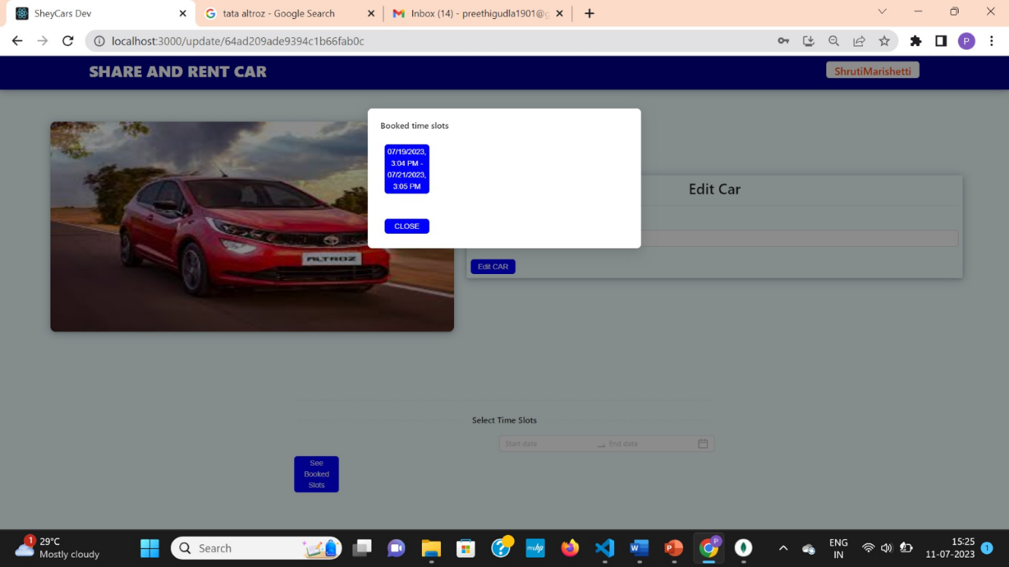

 Fig 6.1.28 Car owner is checking booked time slots before updating available time slots.

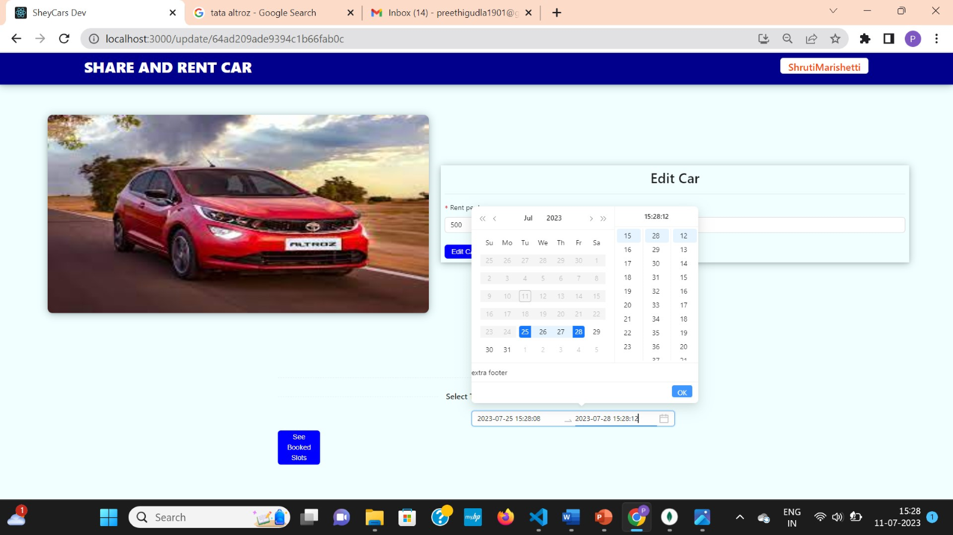

 Fig 6.1.29 Car owner is choosing other than booked time slot to make it unavailable

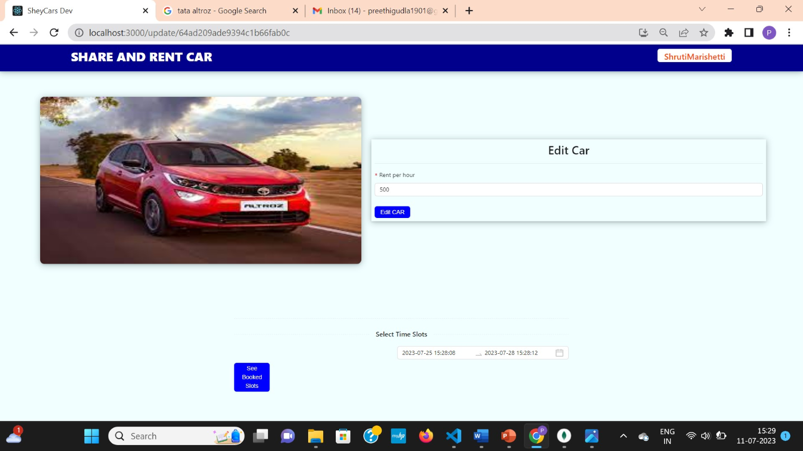

 Fig 6.1.30 car details that can be updated

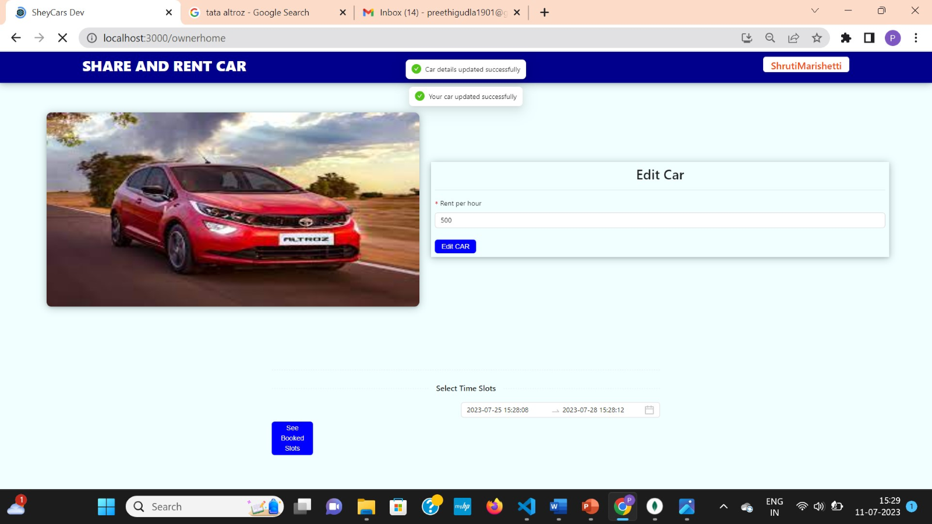

 Fig 6.1.31 Successful editing and updating of car details

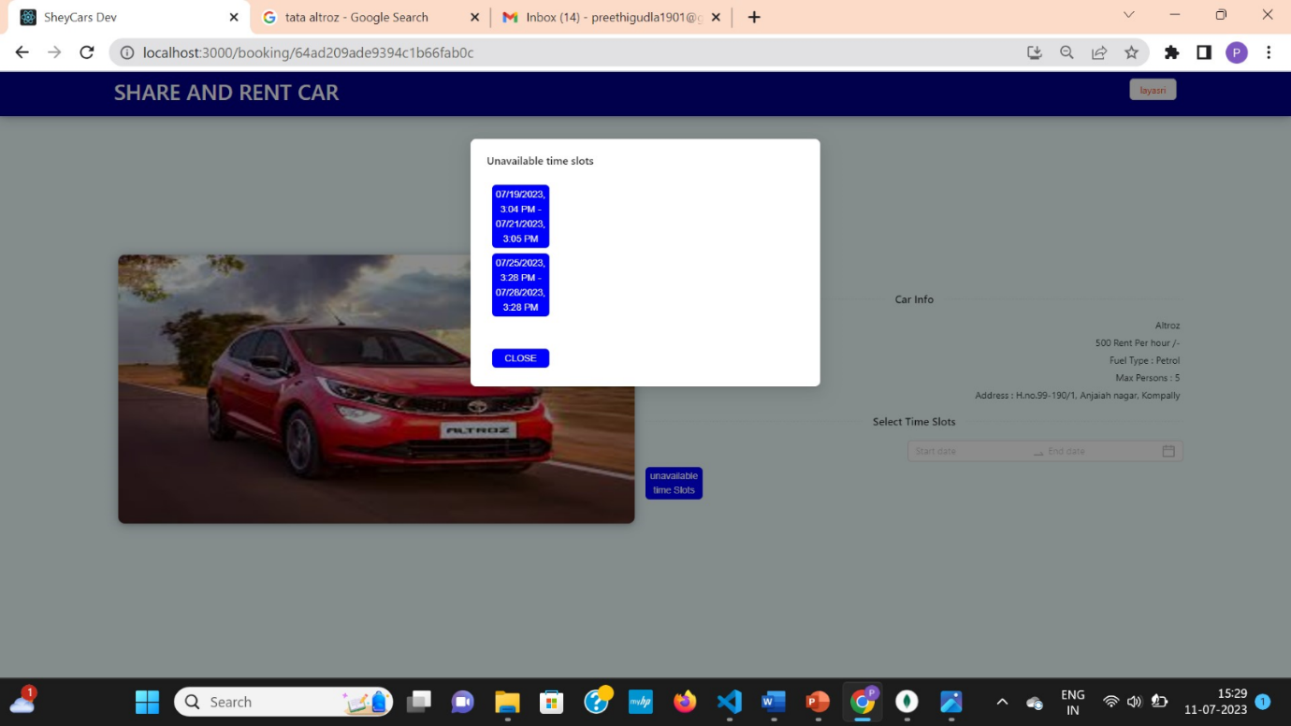

  Fig 6.1.32 Unavailable time slots are updated on customers side

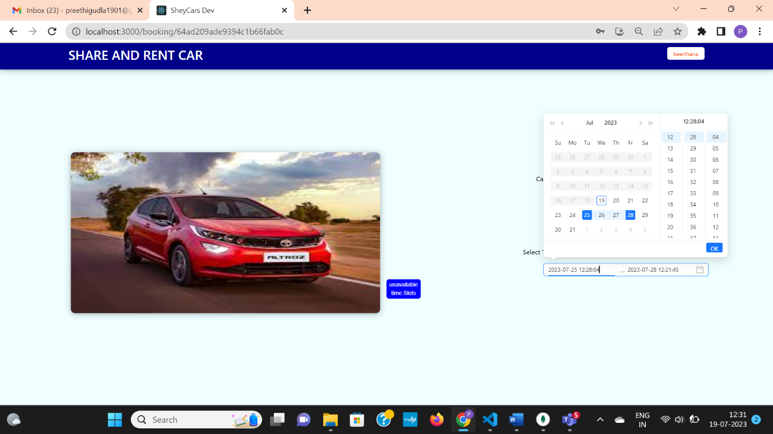

Fig 6.1.33 Customer trying to book car in unavailable time slot

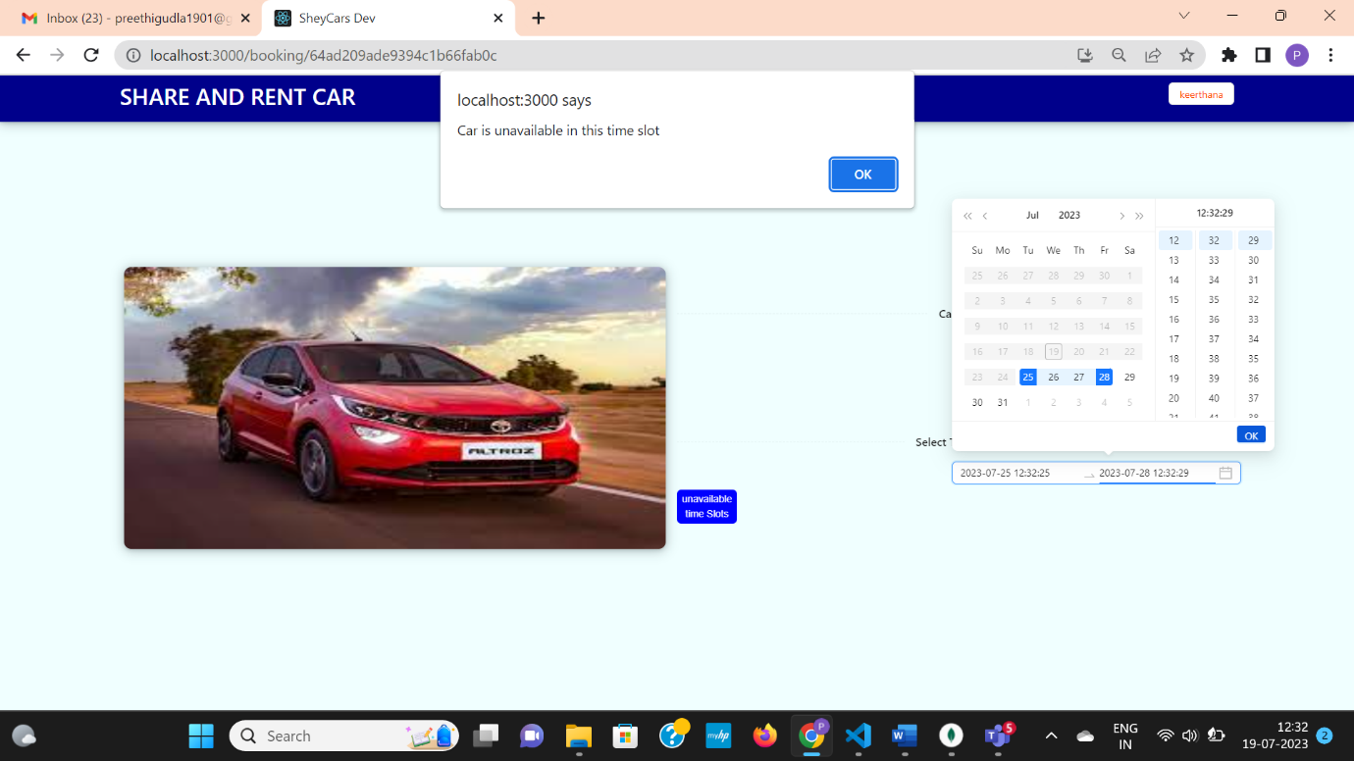

Fig 6.1.34 Customer will be alerted that it is an unavailable time slot

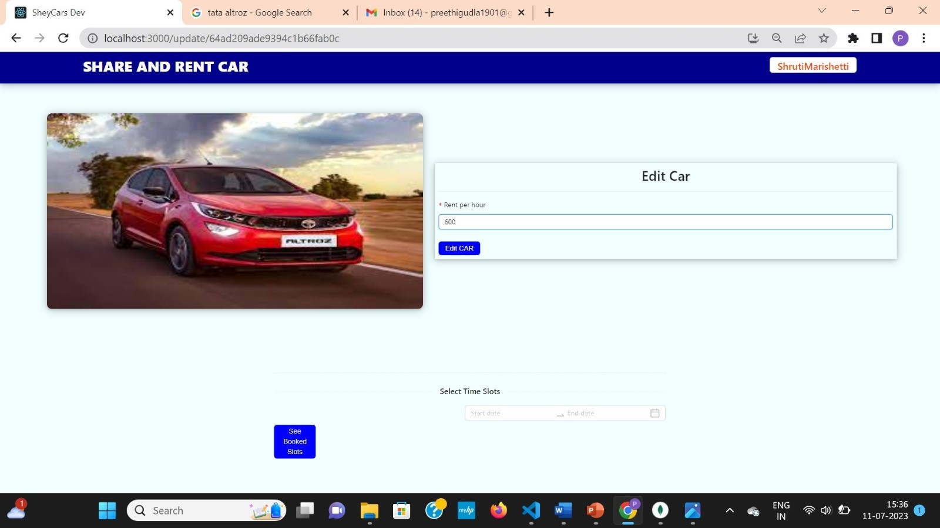

Fig 6.1.35 Car Owner is editing car price to 600 from 500 rs.

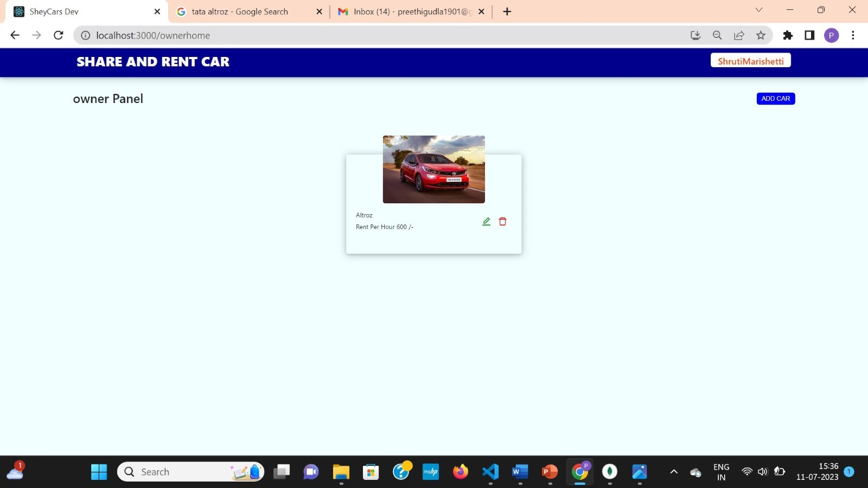

Fig 6.1.36 Car Price is updated at owners car page.

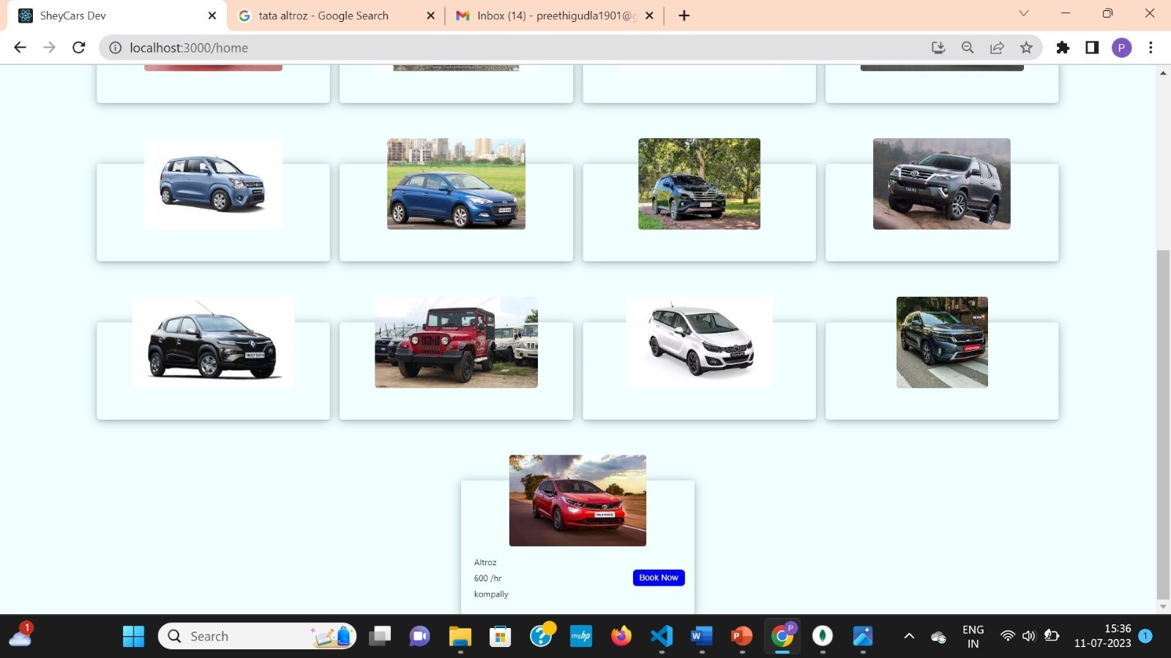

Fig 6.1.37 Car Price is updated at customers car page.

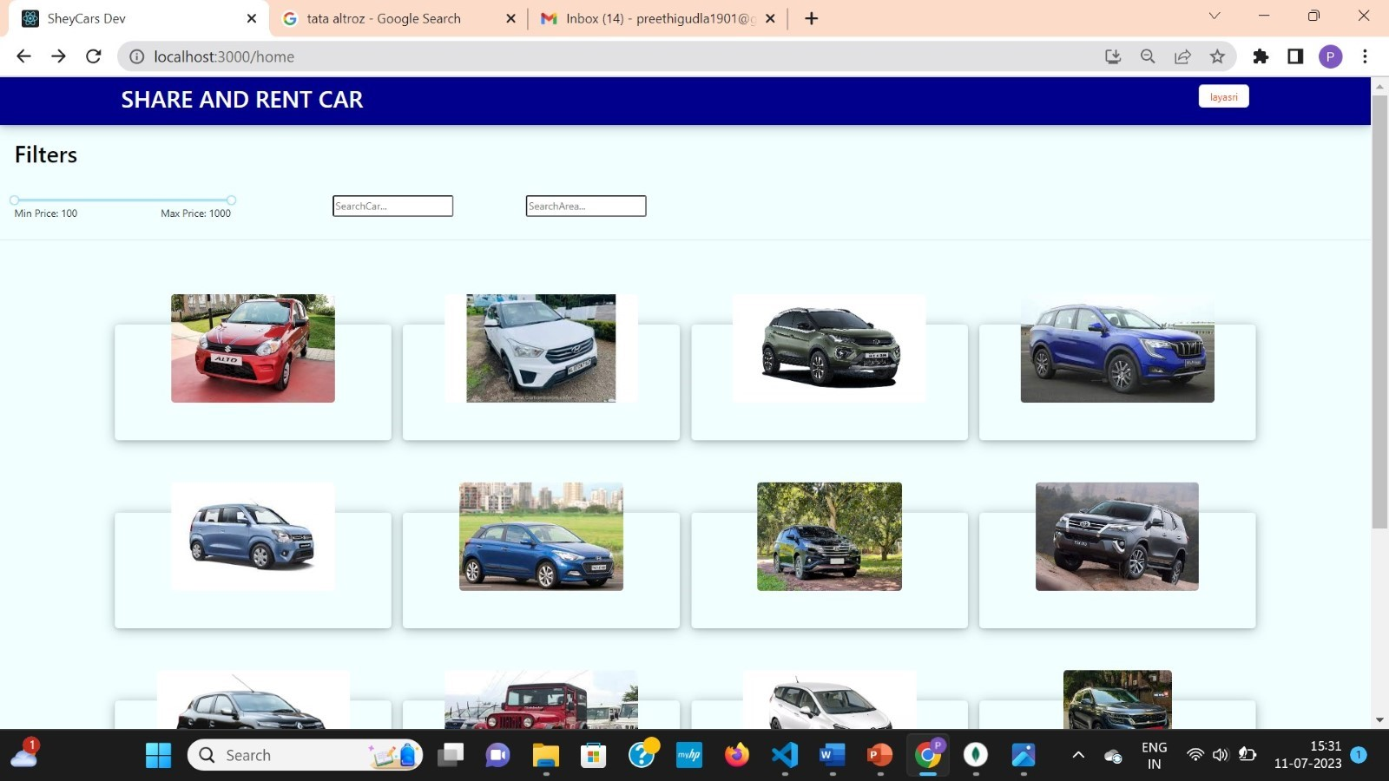

Fig 6.1.38 All cars of website from which particular Car Owner can delete car from website.

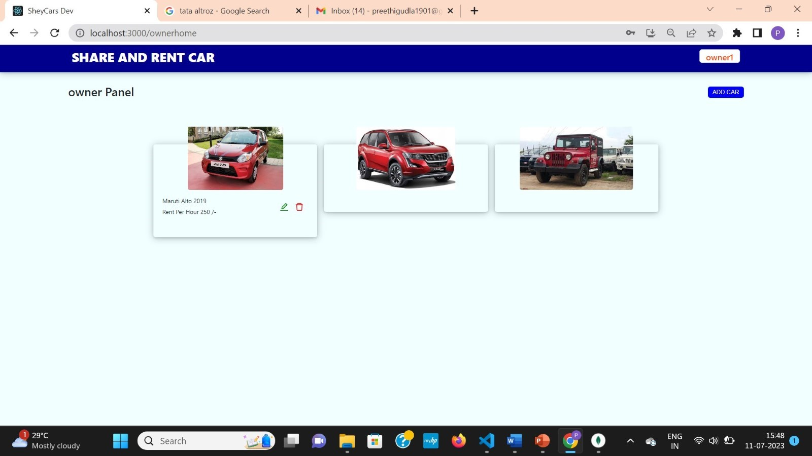

Fig 6.1.39 Car Owner can delete car by clicking on red bin button below car image.

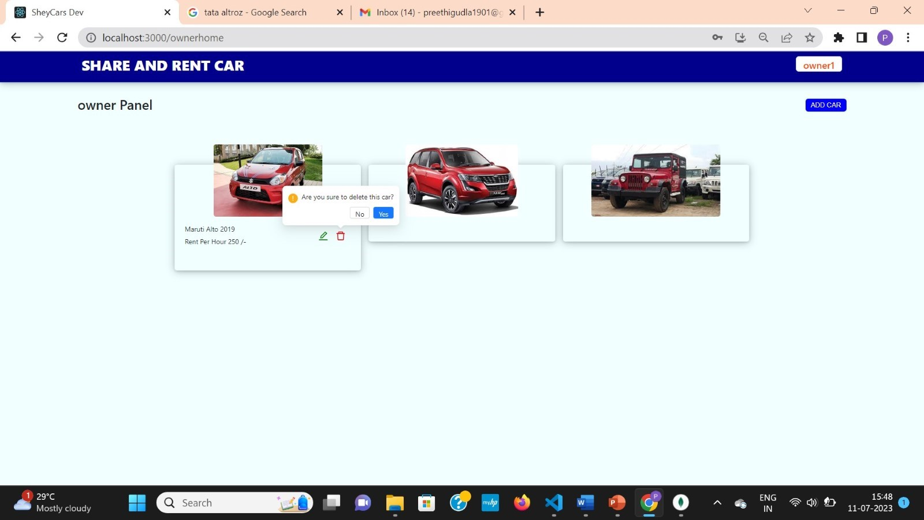

Fig 6.1.40 Car Owner will be asked for confirmation to delete.

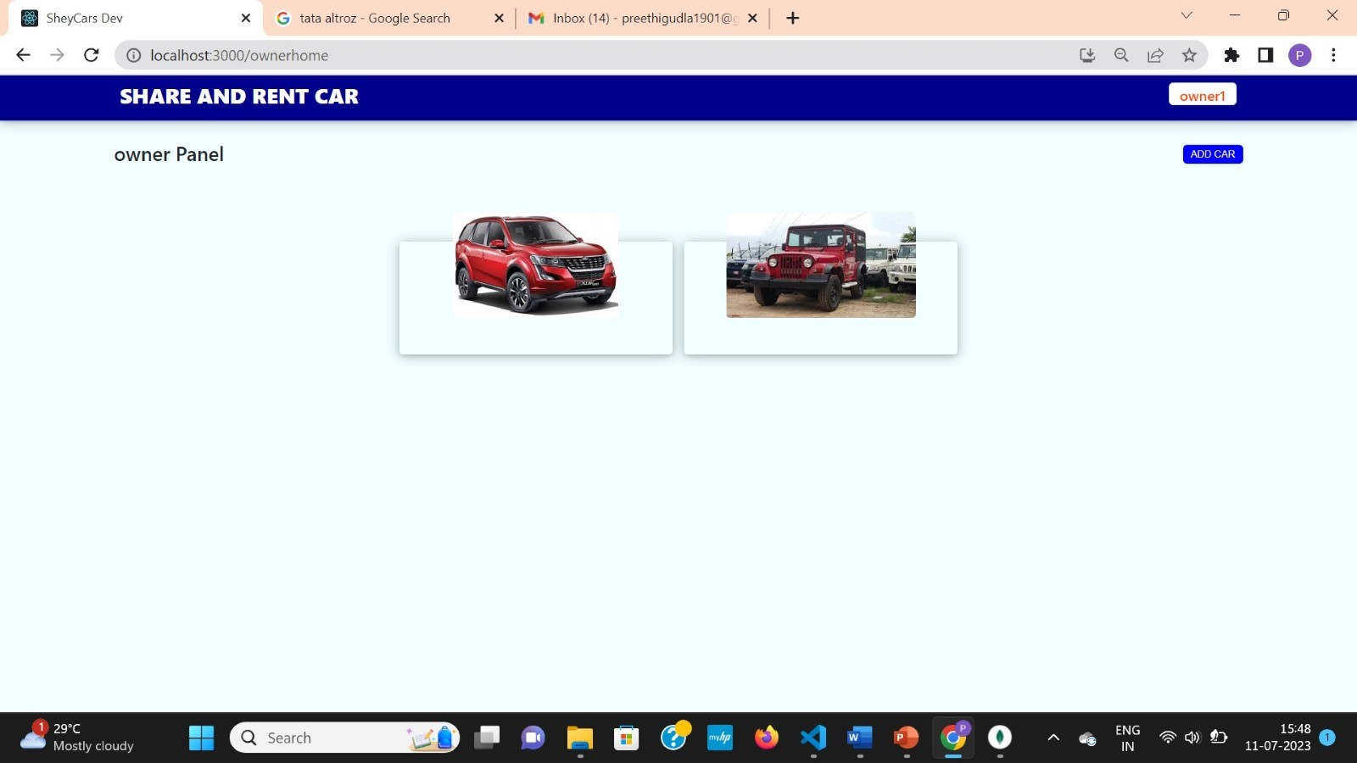

 Fig 6.1.41 Car will be deleted once car owner press yes and it will be removed from website.

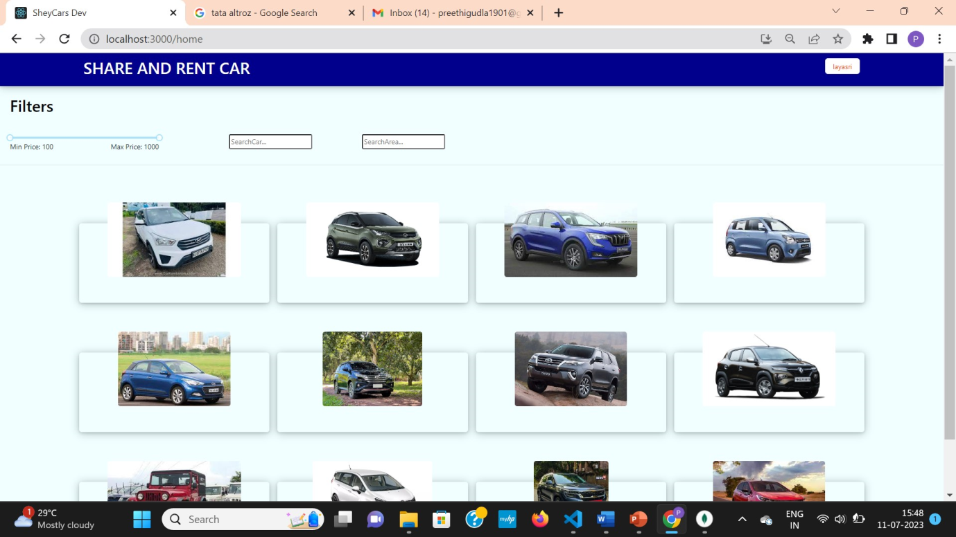

Fig 6.1.42 Car is deleted and removed from website.

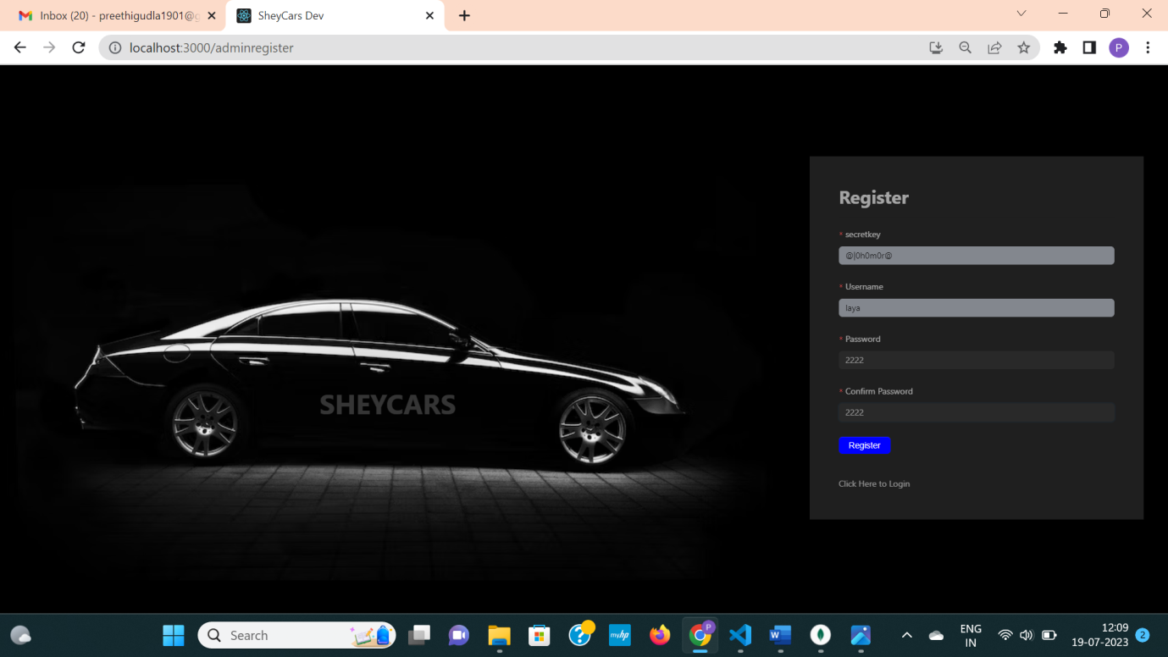

Fig 6.1.43 Admin registers into the website.

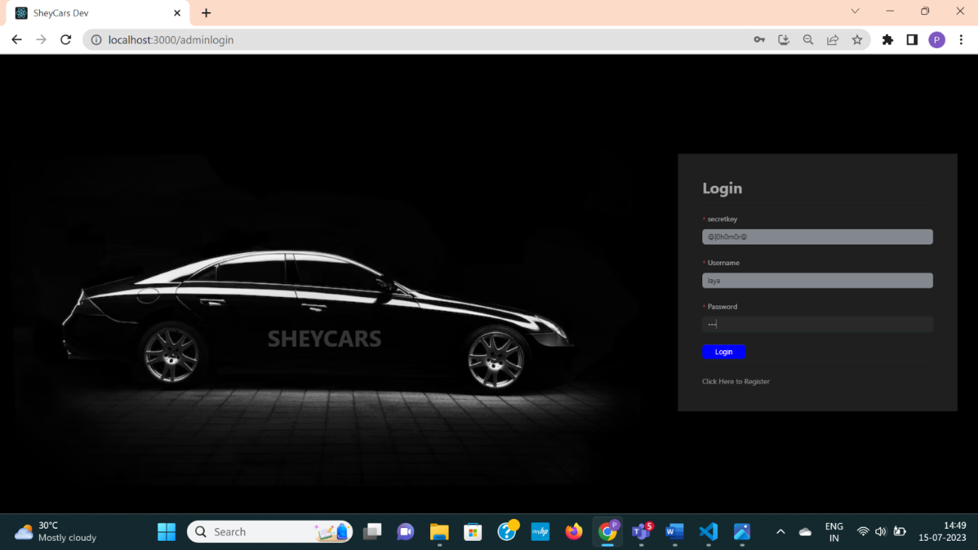

 Fig 6.1.44 Admin login to the account through password and secretkey known only to administrators of website.

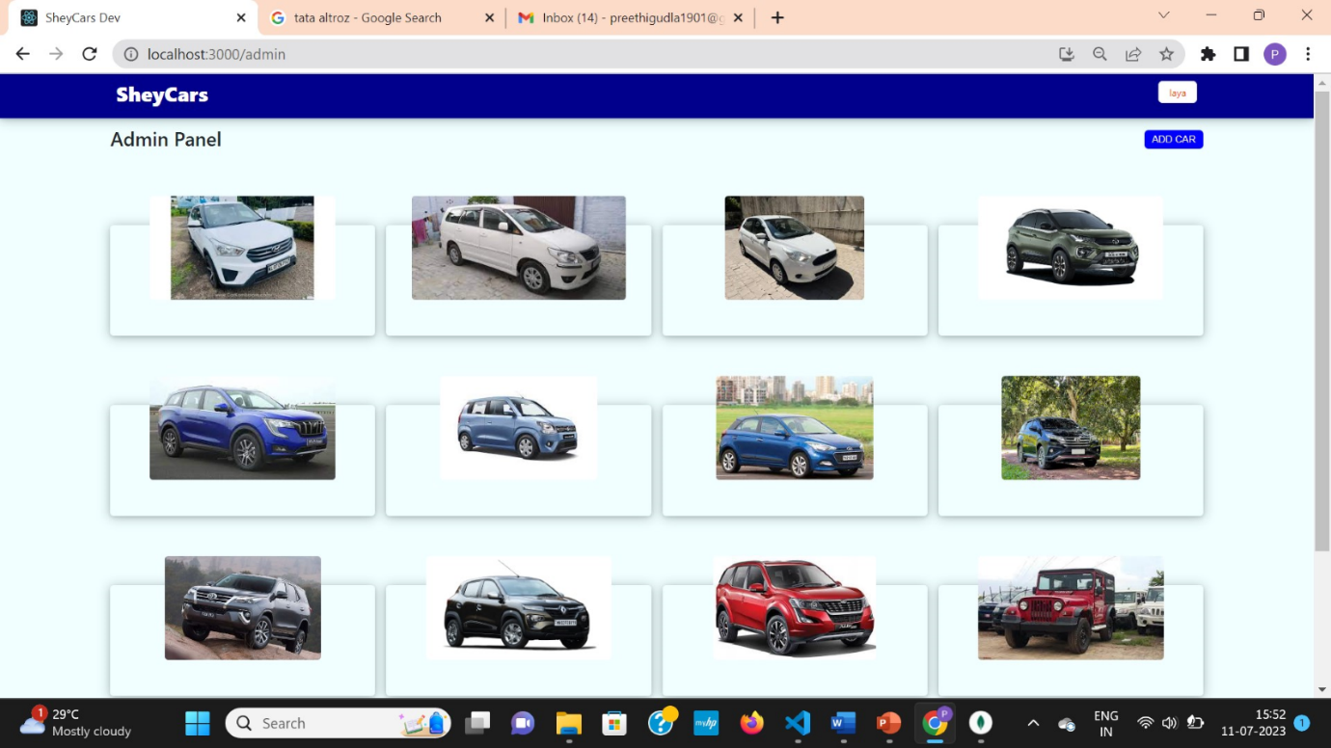

Fig 6.1.45 Admin can view all cars in the website.

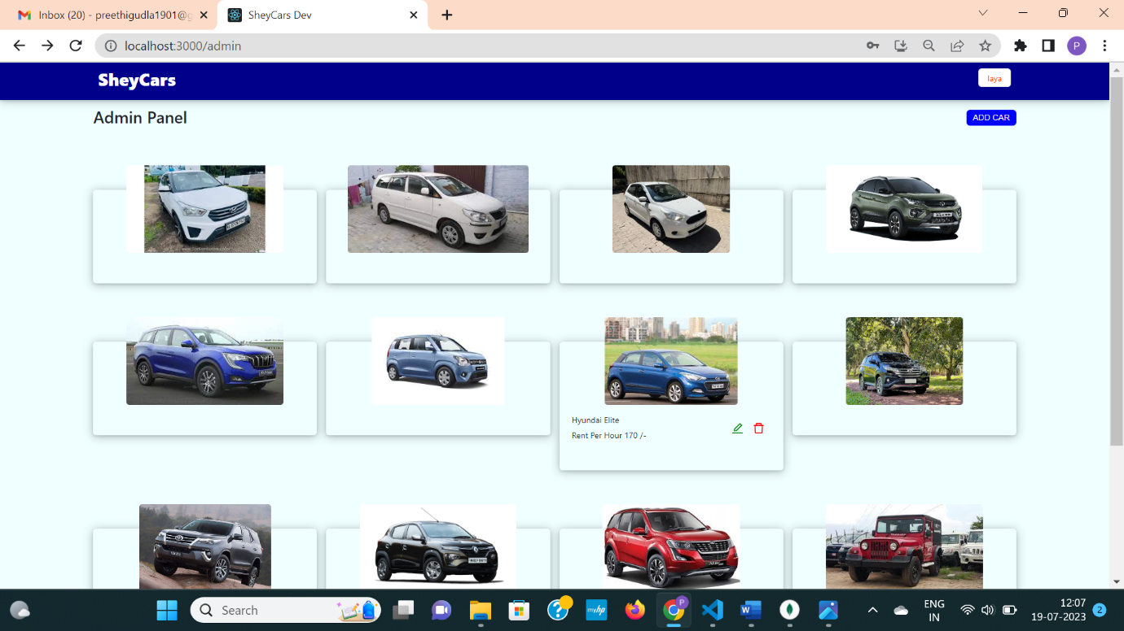

Fig 6.1.46 Admin found one car is uploaded by its car owner with less price and given wrong name.

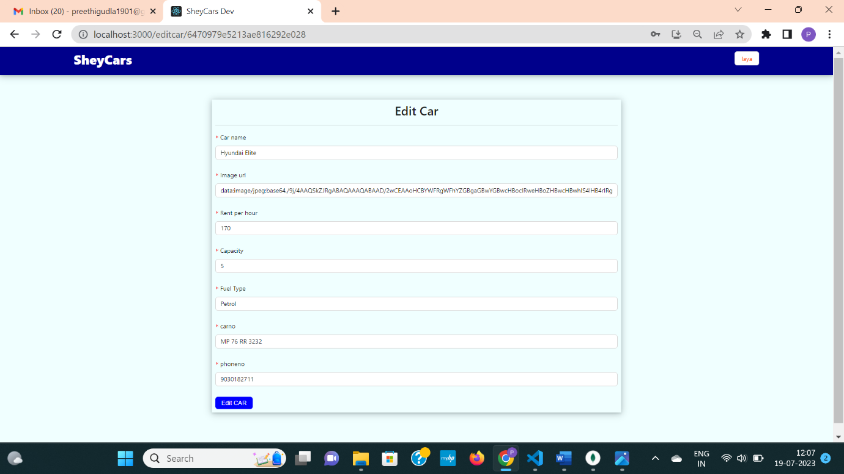

Fig 6.1.47 Admin will be redirected to edit page to edit details.

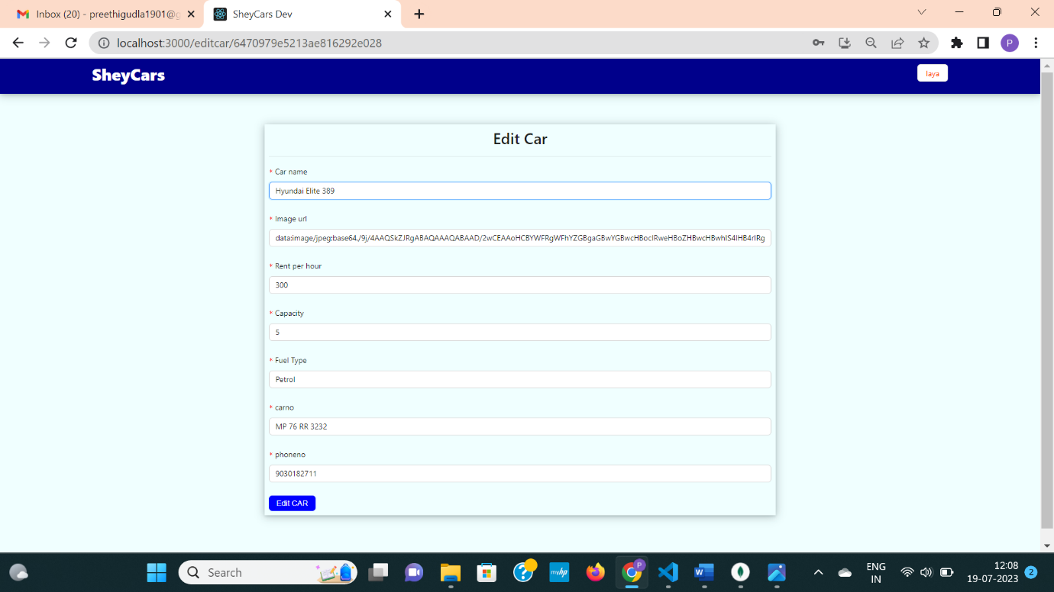

Fig 6.1.48 Admin edited car price and car model.

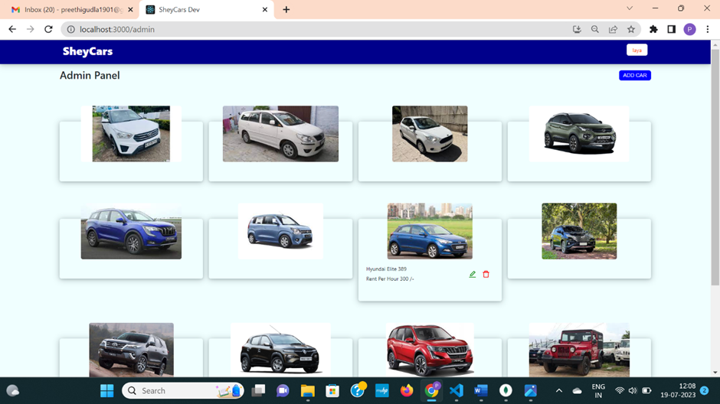

Fig 6.1.49 Car details are updated.

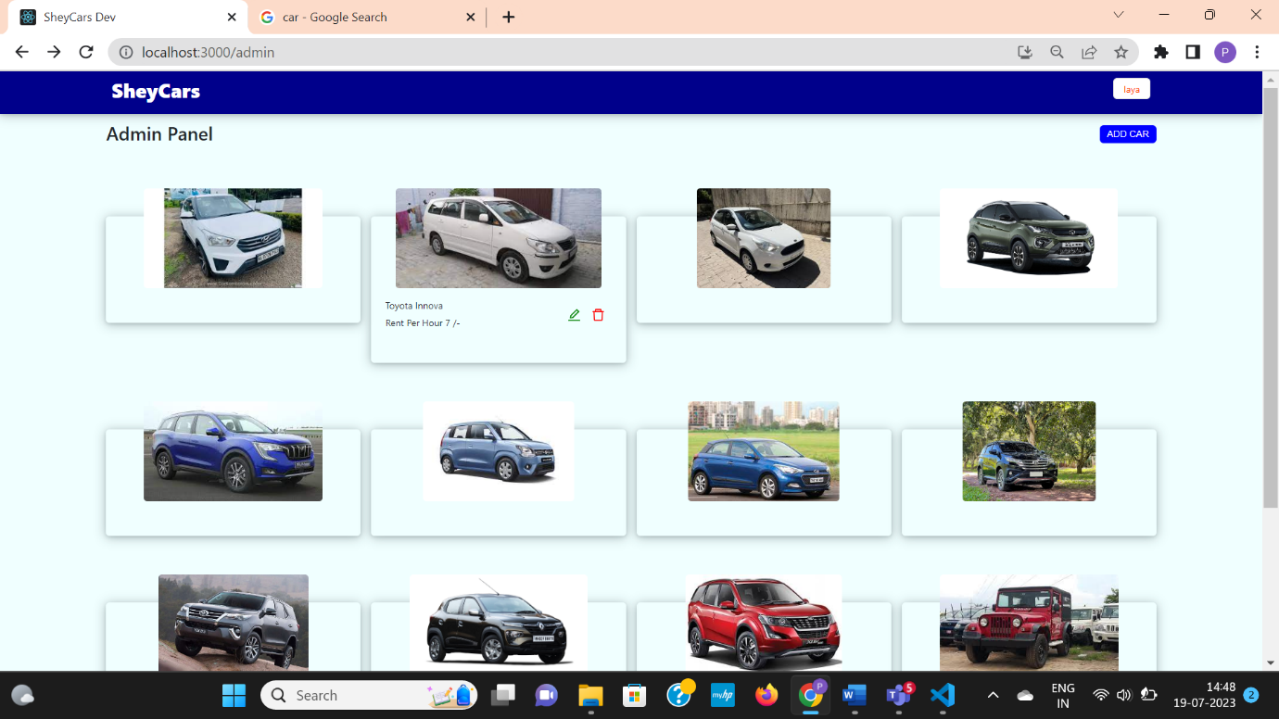

Fig 6.1.50 Admin can delete car from website by clicking on red bin button

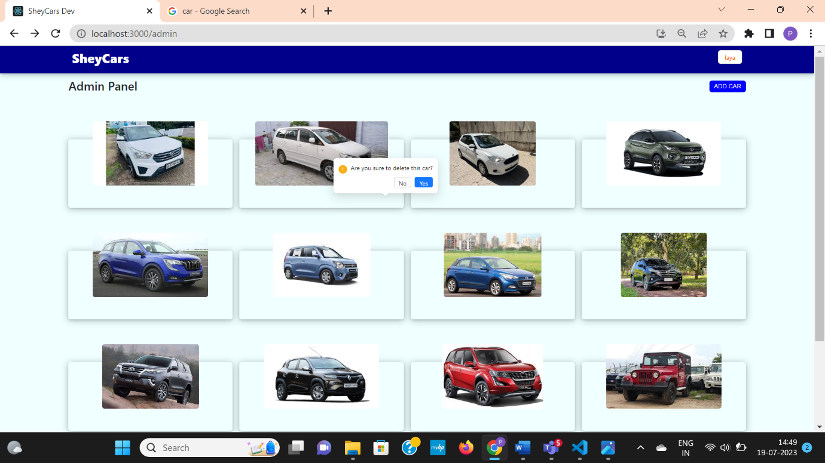

Fig 6.1.51 Admin will be are they are sure to delete car

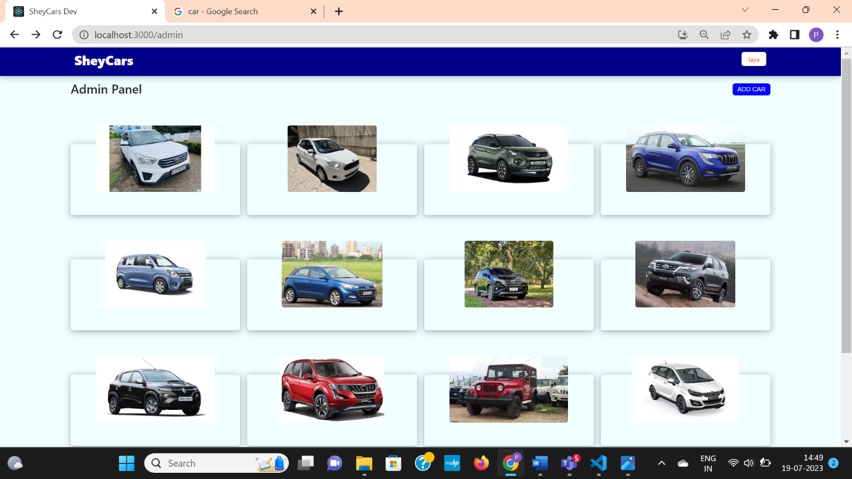

Fig 6.1.52 Car will be deleted from website as soon as admin deleted it.